**React Components**

* In React JS, Components are independent and reusable pieces of code and also called building blocks of react app.
* In React JS, they serve the same purpose as JavaScript functions, but work in isolation (separately) and return HTML or HTML elements.
* In React JS, Components are of two types
  + Class components
  + Function components
* In this Blog, we will concentrate on Function components.

**Functional Components In React JS**

* Components are just like functions that return HTML elements.
* In older React code bases, you may find Class components primarily used.
* In React JS, it is now suggested to use Function components, which were added in React 16.8.

## Understanding WorkFlow Of React APP

## https://learningneverendstech.com/wp-content/uploads/2022/07/image-1.png

## 1st Way Of Working With Functional Components

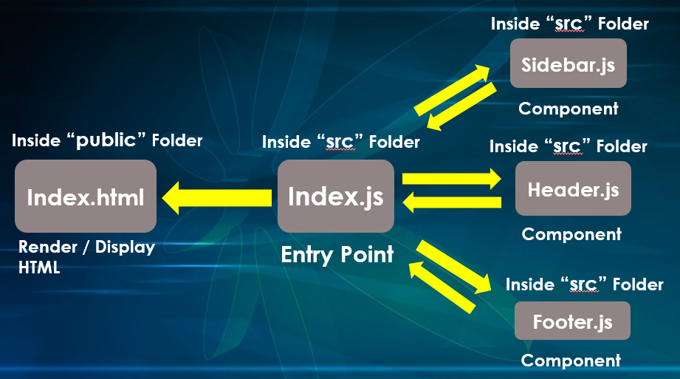

## 2nd Way Of Working With Functional Components

